Constructing Regular Nonagon

Definition
# Source: AI Source: Provided by: [Data Path: Persons Table -> ID Column: 1, Name_En Column: Motasem Essam] -> From: [ChatGPT] on [7/25/2026]
A regular nonagon is a polygon with nine equal sides and nine equal interior angles.
The term nonagon comes from nona meaning nine and gon meaning angle or side.
For a regular nonagon:
$$\boxed{n=9} \\ \boxed{AB=BC=CD=DE=EF=FG=GH=HI=IA}$$
All interior angles are equal, and all central angles formed from the center are equal.

Fundamental Properties
# Source: AI Source: Provided by: [Data Path: Persons Table -> ID Column: 1, Name_En Column: Motasem Essam] -> From: [ChatGPT] on [7/25/2026]
Number of Sides
$$\boxed{9}$$
Number of Vertices
$$\boxed{9}$$
Interior Angle
The measure of each interior angle is:
$$\boxed{\frac{\left(9-2\right){180}^{∘}}{9}={140}^{∘}}$$
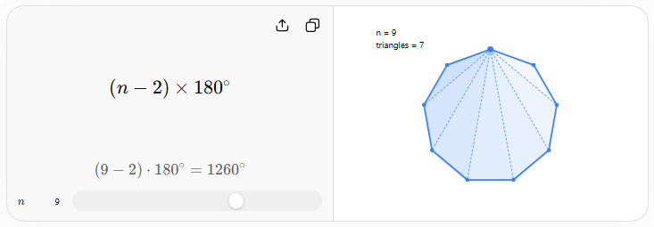
Sum of Interior Angles
$$\boxed{\left(9-2\right){180}^{∘}={1260}^{∘}}$$
Central Angle
A complete circle is ${360}^{∘}$, divided into nine equal parts:
$$\boxed{\frac{{360}^{∘}}{9}={40}^{∘}}$$
Therefore, each central angle of a regular nonagon is:
$$\boxed{{40}^{∘}}$$
Exterior Angle
$$\boxed{{40}^{∘}}$$
For a regular polygon, each exterior angle equals its central angle.

Constructing a Regular Nonagon
# Source: AI Source: Provided by: [Data Path: Persons Table -> ID Column: 1, Name_En Column: Motasem Essam] -> From: [ChatGPT] on [7/25/2026]
The regular nonagon presents an important distinction from polygons such as the regular triangle, square, pentagon, hexagon, and octagon.
A regular nonagon cannot be constructed exactly using only an unmarked straightedge and compass.
This is because exact straightedge-and-compass construction of a regular $n$-gon is possible only when the constructibility conditions are satisfied. Since:
$$9=3^{2}$$
and $3$occurs with a power greater than one, the regular nonagon is not classically constructible.
Therefore, a regular nonagon can be:
- constructed approximately with classical tools;
- constructed exactly with additional tools or numerical methods;
- constructed from a computer-generated regular polygon.

Approximate Construction from a Circumcircle
# Source: AI Source: Provided by: [Data Path: Persons Table -> ID Column: 1, Name_En Column: Motasem Essam] -> From: [ChatGPT] on [7/25/2026]
A practical geometric construction begins with a circle.
Steps
- Draw a circle with center $O$.
- Draw a radius $OA$.
- The required central angle is:
$${40}^{∘}$$
- Construct or approximate a ${40}^{∘}$central angle at $O$.
- Mark the next point $B$on the circle.
- Continue marking points separated by approximately ${40}^{∘}$.
- Continue until nine points are obtained:
$$A,B,C,D,E,F,G,H,I$$
- Connect consecutive points.
The result is an approximate regular nonagon.

Construction from a Given Circumradius
# Source: AI Source: Provided by: [Data Path: Persons Table -> ID Column: 1, Name_En Column: Motasem Essam] -> From: [ChatGPT] on [7/25/2026]
If the circumradius $R$is known, the side length $s$is:
$$\boxed{s=2R\sin{{20}^{∘}}}$$
because each side subtends a central angle of:
$${40}^{∘}$$
and half of that angle is:
$${20}^{∘}$$
Thus, the side can be determined numerically and then transferred around the circle.

Construction from a Given Side
# Source: AI Source: Provided by: [Data Path: Persons Table -> ID Column: 1, Name_En Column: Motasem Essam] -> From: [ChatGPT] on [7/25/2026]
If the side length $s$is known, the circumradius is:
$$\boxed{R=\frac{s}{2\sin{{20}^{∘}}}}$$
The apothem is:
$$\boxed{a=\frac{s}{2\tan{{20}^{∘}}}}$$
These formulas allow an exact numerical construction even though a classical straightedge-and-compass construction is impossible.

Construction from a Given Center
# Source: AI Source: Provided by: [Data Path: Persons Table -> ID Column: 1, Name_En Column: Motasem Essam] -> From: [ChatGPT] on [7/25/2026]
If the center $O$and circumradius $R$are given:
- Draw the circumcircle.
- Divide the circle into nine equal ${40}^{∘}$central sectors.
- Mark the nine vertices.
- Connect consecutive vertices.
The result is a regular nonagon.
The difficulty is that exactly constructing ${40}^{∘}$with only straightedge and compass is not possible.

Mathematical Properties
# Source: AI Source: Provided by: [Data Path: Persons Table -> ID Column: 1, Name_En Column: Motasem Essam] -> From: [ChatGPT] on [7/25/2026]
Side Length
If the circumradius is $R$:
$$\boxed{s=2R\sin{{20}^{∘}}}$$
Circumradius
$$\boxed{R=\frac{s}{2\sin{{20}^{∘}}}}$$
Apothem
$$\boxed{a=\frac{s}{2\tan{{20}^{∘}}}}$$
Perimeter
$$\boxed{P=9s}$$
Area
Using:
$$A=\frac{1}{2}Pa$$
we obtain:
$$\boxed{A=\frac{9}{2}sa}$$
or, in terms of the circumradius:
$$\boxed{A=\frac{9}{2}R^{2}\sin{{40}^{∘}}}$$

Symmetry
A regular nonagon has:
Lines of Symmetry
$$\boxed{9}$$
Each symmetry axis passes through one vertex and the midpoint of the opposite side.
Rotational Symmetry
The regular nonagon has rotational symmetry of order:
$$\boxed{9}$$
The smallest non-zero rotation is:
$$\boxed{{40}^{∘}}$$
The polygon maps onto itself after rotations of:
$${40}^{∘}, {80}^{∘}, {120}^{∘},…,{320}^{∘}$$

Types / Construction Situations
# Source: AI Source: Provided by: [Data Path: Persons Table -> ID Column: 1, Name_En Column: Motasem Essam] -> From: [ChatGPT] on [7/25/2026]
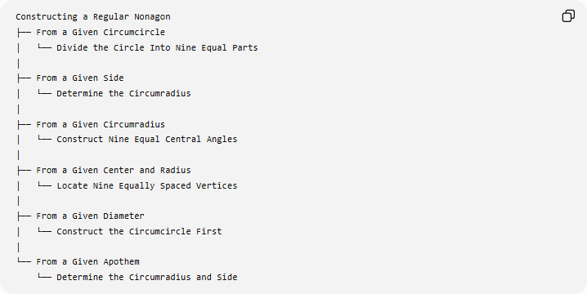
Constructing a Regular Nonagon
├── From a Given Circumcircle
│ └── Divide the Circle Into Nine Equal Parts
│
├── From a Given Side
│ └── Determine the Circumradius
│
├── From a Given Circumradius
│ └── Construct Nine Equal Central Angles
│
├── From a Given Center and Radius
│ └── Locate Nine Equally Spaced Vertices
│
├── From a Given Diameter
│ └── Construct the Circumcircle First
│
└── From a Given Apothem
└── Determine the Circumradius and Side
Classification note: these are different construction situations, rather than different mathematical types of regular nonagons.

Basic Constructions Used
# Source: AI Source: Provided by: [Data Path: Persons Table -> ID Column: 1, Name_En Column: Motasem Essam] -> From: [ChatGPT] on [7/25/2026]
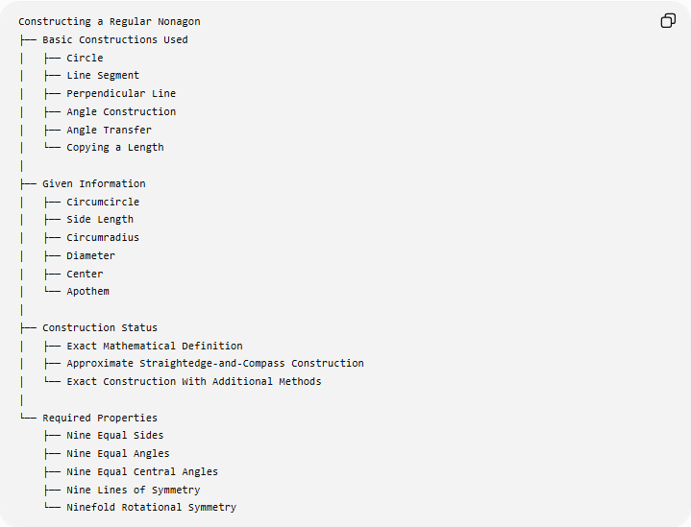
Constructing a Regular Nonagon
├── Basic Constructions Used
│ ├── Circle
│ ├── Line Segment
│ ├── Perpendicular Line
│ ├── Angle Construction
│ ├── Angle Transfer
│ └── Copying a Length
│
├── Given Information
│ ├── Circumcircle
│ ├── Side Length
│ ├── Circumradius
│ ├── Diameter
│ ├── Center
│ └── Apothem
│
├── Construction Status
│ ├── Exact Mathematical Definition
│ ├── Approximate Straightedge-and-Compass Construction
│ └── Exact Construction With Additional Methods
│
└── Required Properties
├── Nine Equal Sides
├── Nine Equal Angles
├── Nine Equal Central Angles
├── Nine Lines of Symmetry
└── Ninefold Rotational Symmetry

Classification in Geometric Construction
# Source: AI Source: Provided by: [Data Path: Persons Table -> ID Column: 1, Name_En Column: Motasem Essam] -> From: [ChatGPT] on [7/25/2026]
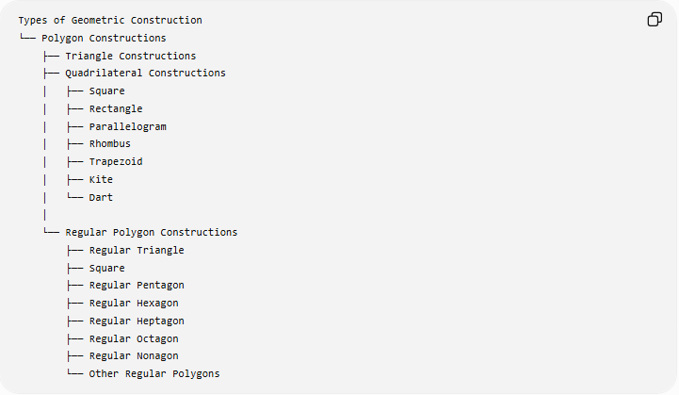
Types of Geometric Construction
└── Polygon Constructions
├── Triangle Constructions
├── Quadrilateral Constructions
│ ├── Square
│ ├── Rectangle
│ ├── Parallelogram
│ ├── Rhombus
│ ├── Trapezoid
│ ├── Kite
│ └── Dart
│
└── Regular Polygon Constructions
├── Regular Triangle
├── Square
├── Regular Pentagon
├── Regular Hexagon
├── Regular Heptagon
├── Regular Octagon
├── Regular Nonagon
└── Other Regular Polygons

Comparison With Previous Regular Polygons
# Source: AI Source: Provided by: [Data Path: Persons Table -> ID Column: 1, Name_En Column: Motasem Essam] -> From: [ChatGPT] on [7/25/2026]
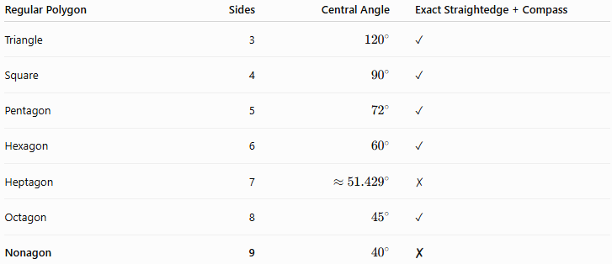
Regular Polygon | Sides | Central Angle | Exact Straightedge + Compass
Triangle | 3 | $${120}^{∘}$$ | ✓
Square | 4 | $${90}^{∘}$$ | ✓
Pentagon | 5 | $${72}^{∘}$$ | ✓
Hexagon | 6 | $${60}^{∘}$$ | ✓
Heptagon | 7 | $$≈{51.429}^{∘}$$ | ✗
Octagon | 8 | $${45}^{∘}$$ | ✓
Nonagon | 9 | $${40}^{∘}$$ | ✗
The important point is that the regular nonagon is not exactly constructible with classical straightedge and compass, just as the regular heptagon is not.

Key Points
# Source: AI Source: Provided by: [Data Path: Persons Table -> ID Column: 1, Name_En Column: Motasem Essam] -> From: [ChatGPT] on [7/25/2026]
- A regular nonagon has 9 equal sides.
- It has 9 equal interior angles.
- Each interior angle is:
$$\boxed{{140}^{∘}}$$
- The sum of its interior angles is:
$$\boxed{{1260}^{∘}}$$
- Each central angle is:
$$\boxed{{40}^{∘}}$$
- It has 9 lines of symmetry.
- It has rotational symmetry of order 9.
- Its perimeter is:
$$\boxed{P=9s}$$
- Its area is:
$$\boxed{A=\frac{9}{2}sa}$$
- For circumradius $R$:
$$\boxed{s=2R\sin{{20}^{∘}}}$$
- A regular nonagon cannot be constructed exactly using only an unmarked straightedge and compass.
- It can nevertheless be represented exactly by mathematical formulas or constructed exactly using additional methods.

Conclusion
# Source: AI Source: Provided by: [Data Path: Persons Table -> ID Column: 1, Name_En Column: Motasem Essam] -> From: [ChatGPT] on [7/25/2026]
A regular nonagon is a nine-sided regular polygon with nine equal sides, nine equal interior angles of ${140}^{∘}$, and central angles of ${40}^{∘}$. Unlike the regular octagon, its ${40}^{∘}$division cannot be obtained exactly using only classical straightedge-and-compass constructions. Therefore, its construction is normally treated as an approximate classical construction or an exact numerical/computer construction.

